Influence of Accounting Practices on performance
2011

Of AstraZeneca and Eli Lilly

Table of Contents
1
PART A p.2
Accounting policies of AstraZeneca and Eli Lilly
PART B p.5
Disclosure of voluntary reports
PART C p.9
Financial Statement Ratios
PART D .p.16
International Corporate Reporting
PART E p.18
Non-Financial Performance Indicators

Introduction
2
This report aims to analyse the financial performance of two pharmaceutical companies, the companies under study are AstraZeneca – A United Kingdom Based Pharmaceutical Major and Eli Lilly- An American Company. This report covers the influence of different accounting and reporting practices adopted by the two companies on the financial position and overall performance of the company. On comparing the two company’s annual reports some key financial information could be obtained.
Part A
Accounting policies of AstraZeneca and Eli Lilly
AstraZeneca prepares its financial statements in accordance with International Financial Reporting Standards (IFRS) while Eli Lilly prepares its statements in accordance to Generally Accepted Accounting principles (GAAP). Some differences in the accounting policies of these two companies which may affect the evaluation of the performance of the company are as follows:
Revenue
The revenue of AstraZeneca is mainly from sales, earnings from co-promotion and co-development agreements while income for Eli Lilly include earnings from sales, co-promotion, out-licensing agreements, Collaboration agreements, co-development agreements and royalty revenue from licenses.
● Sales
- AstraZeneca
They consider income from sales of product only after the risks and reward of ownership is completely transferred to the buyer i.e. on delivery of the product. These revenues do not include value added taxes, and represent net invoice which is after settlement discounts, returns and rebates.
- Eli Lilly
In contrast Lilly, for 85% of its sales recognizes the revenue once the product is shipped to its customers and the rest sales are recorded once product is
delivered. Discounts and rebates are recorded as a part of this revenue.
● Co-Promotion and Co-Development
- AstraZeneca
This is recognized once the income is earned i.e. upon the sale of the co-promoted/ developed product.

o Eli Lilly
i
3
This is based on net sales recorded by the company’s co- promotion partners and the amount of sales calls.
● Licensing Agreements
Eli Lilly is known to earn an income from advance payment received from out-licensing agreement. This includes the license to market and sell the product and is considered in the net product sales as per the conditions stated in the supply agreement.
Cash Equivalents
● Eli Lilly
All highly liquid investments having a maturity of 3 months or less from date of purchase are considered as cash equivalents.
● AstraZeneca
These include current balances with banks and similar institutions, cash in hand and highly liquid investments having maturity of 3 months or less.
Inventories
Both the companies state their inventories at lower of cost and net realizable value.
● Eli Lilly
They use the last-in, first-out (LIFO) method for 45% of its total inventories and the remaining are valued by first-in, first-out (FIFO) method. FIFO is valued based on approximates current replacement cost.
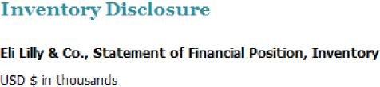

● AstraZeneca
4
They use a first-in, first-out (FIFO) or an average valuation method. For finished goods and work in progress, costs include direct costs and some overhead expenses. Selling expenses and other overhead expenses such as central administration costs are excluded.
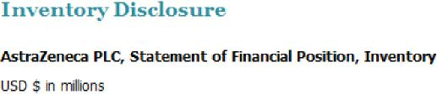
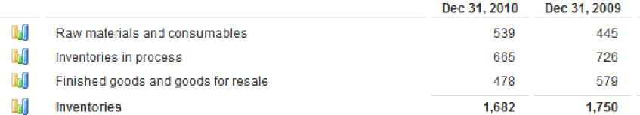
ii
Property and Equipment
● Eli Lilly
This is stated on cost basis and directly depends on the life of the property and equipment (12-50 yrs for building, 3-18yrs for equipment). The carrying values of long lived assets are reviewed on periodic basis. Impairment is calculated by comparing the not discounted cash flows to be generated by an asset to its carrying value. On identifying impairment, a loss is declared equal to the asset’s net book value over its fair value and cost is accordingly modified.
● AstraZeneca
Reviews of cost of assets are made on an annual basis. The company follows the policy to write off the difference between each and every asset and its residual value over its estimated life (10-50years buildings, 13 years equipment). All properties, equipment are checked for impairment on indications that the carrying value may not be recoverable. Impairment losses are recognized as profits.
Research and Development
● Eli Lilly
R&D is considered as an expense. The expenses include R&D costs which are expensed; milestone payments incurred before regulatory drug approval are accrued at the time of payment. Acquired IPR&D expense include, initial IPR&D project cost while acquiring the asset, fair values of projects obtained in business

combination before 2009 while those obtained post 2009 are capitalized as other intangible assets.
5
● AstraZeneca
Expenditure on R&D is recognized in profit. Payments to third party in the type of upfront payment and milestones for in-licensing products are capitalized. However, payments for future research are evaluated based on the nature of payment and are recognized as expense if it is a compensation for subcontracted R&D not resulting in transfer of intellectual property.
Taxation
Both companies recognize deferred tax based on enacted tax laws and rates. For AstraZeneca, no differed tax is recognized for temporary differences in investment in subsidiaries, branches and joint ventures as it is probable that differences will not reverse in future. Both companies recognize tax benefits from uncertain tax position only if it is more likely that the position will be sustained by taxing authorities. Eli Lilly measures benefits from such position based on largest benefit that has more than 50% likelihood of being realized. For AstraZeneca, once a benefit is probable, management reviews each benefit to assess whether a provision should be made for full recognition of that benefit.
Part B
The two companies under study belong to two different countries and each one of them has a unique style of representation, strategic approaches, implementation and a distinctive format and mode of disclosure.
On taking a quick glimpse at the overall Annual report of the two companies, it is clearly visible that AstraZeneca mainly highlights the financial performance of the company while Eli Lilly states comprehensive information on the current business trends and the future prospects of the company.

Disclosure of information in Voluntary Reports

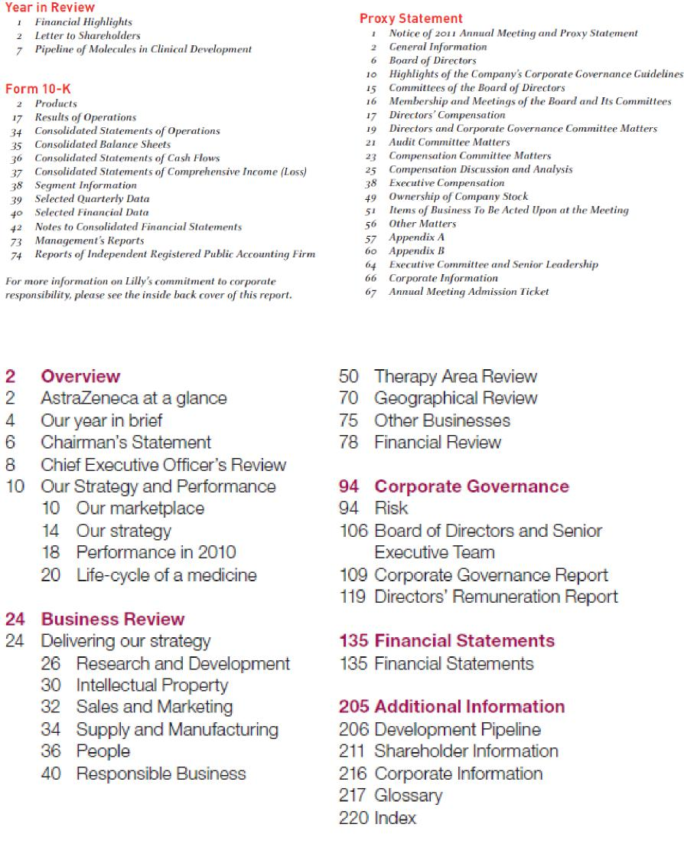
Eli Lilly’s content of Annual report 2010
AstraZeneca’s content of Annual report 2010
6
The Chairman’s Report, Chief Executive Officer’s Statement and the Management Report of the two companies have been studied to discover the amount of information disclosed by the two companies and identify information that has been kept discrete.

Research and Development
7
This is the most important factor for understanding the performance of a pharmaceutical Company. Eli Lily gives detailed information on the pipeline of molecules (drugs) in clinical development, its successful launch of new molecules and failure on conducting efficient research on few molecules and the attempt to patent these molecules. In Contrast, AstraZeneca’s management gives a brief description on the success and failure of a few molecules and underlines the failure of its research and development in the past and its successful endeavour to improve it in the current year.
Shareholders Information
AstraZeneca’s Management discloses precise information to its shareholders. It speaks of the current cash flows in the company, the amendments in dividend policy, declares the growth in issue of dividends and highlights the expected growth of the company over the next 5 years. In Contrast, Eli Lilly’s management reports does not reveal much information to its shareholders. It just talks about maintaining dividend to its shareholders.
Performance
The information on the current performance has been equally declared by both the companies. While AstraZeneca provides insights on the worlds current pharmaceutical market trends and its contribution to this market, the growth obstacles and reveals strategies adopted to improve performance. Eli Lilly highlights the revenue earned from its key molecules and brings to light its leading position in the diabetes segment.
Business Strategy
AstraZeneca’s Chairman limits the disclosure of its business strategy to the new production technologies adopted. He gives a general idea on the markets the company intends to consider for expansion and limits this information by using industry terminologies like regulated markets (markets having high influence of government norms). Brief information on the collaborations with foreign companies and their markets has been disclosed. Eli Lilly does not disclose any information on its production technology. However, the management statement does highlight the markets it considers lucrative for investing (e.g. China). It gives detailed information on collaborations, licensing agreement, joint ventures with foreign companies.

Legal
AstraZeneca optimistically points out to the solution and the action taken by the company to resolve pending disputes on various molecules, sales and marketing techniques, etc. while Eli Lilly describes its legal proceedings on current and pending disputes and its negative impact on the sales of the disputed molecule.
Corporate Social Responsibility
The Management at AstraZeneca highlights the good reputation of the company by declaring its contribution to social responsibility and speaks of its refined plan for the year. In contrast, management at Eli Lilly does not declare any such information.
Part C
Profitability Ratios
● Return on Capital Employed
The return on capital employed has decreased from 2009 by 3%. This is mainly because the company’s investment in equity has increased while its long term debt has decreased marginally in comparison to the previous year. This highlights an overall increase in investment which is not supplemented with a proportionate increase in profits for the year 2010.
40%
30%
33% 33%
20%
10%
0%
2010
Return on Capital Employed
37%
40%
2009
Astrazeneca Eli Lilly

In contrast, Eli Lilly has the same the return on capital employed. This is mainly because a proportionate increase in profits and equity is observed in comparison with the previous year.
8

● Gross Profit (%)
9
Gross and Net Profit % (2009 and 2010)
The gross profit percentage of AstraZeneca has decreased in comparison to the previous fiscal. This is because of an increase in the cost of sales which is mainly due to an increase in the cost of raw materials and consumables from 445 $million in 2009 to 539 $million in 2010. In comparison the gross profit percentage for Eli Lilly has increased by a small margin of 0.53% which is in alignment with the marginal increase in revenues from 2009 to 2010.

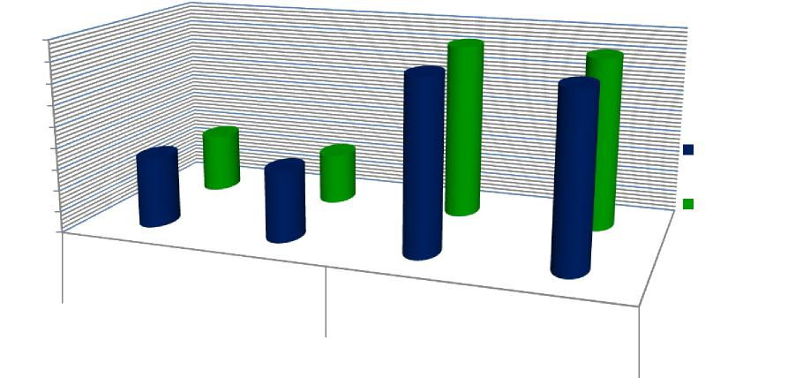
Net profit %
2010
82% 81.08%
Astrazeneca Eli Lilly
28%
24%
81% 80.50%
33%%
33%
2010
2009
Gross Profit %
90%
80%
70%
60%
50%
40%
30%
20%
10%
0%
2009
● Net Profit (%)
The net profit percentage of AstraZeneca has remained constant for 2009 and 2010 in spite of a decline of 1% in the gross profit. A decline in gross profit complimented by an increase in sales means that the company may incur a higher expenditure to sell its goods which is sold at the same cost. However, investigations suggest that the decline in the administration costs and finance expense has caused the net profit of 2010 to be similar to that of 2009.
In contrast, Eli Lilly has increased its net profit by 4% in 2010 despite of the gross profit for the company being constant over the two years. This is mainly because of a decline in the expenditure on Asset impairments and other special charges by 86% and Product liability and other special charges—(legal settlement) by 100%.

Liquidity Ratios
10
● Current and Quick Asset Ratio
This ratio helps identify the company’s ability to meet its liabilities on a short term basis. The Current ratio of AstraZeneca has increased from 1.35 in 2009 to 1.50 in 2010 which is an indication that the company has strong and improving liquidity. A further increase in the current ratio from 1.5:1 to 2:1 will enable the company to be in a better position to meet any unprecedented financial crisis.
The quick ratio of the company also has improved from the previous year. This indicates the capability of the company to meet immediate obligations and short term solvency. However, a further improvement in quick asset ratio would not be advisable. A quick asset ratio of 1:1 is considered to be ideal. The improvement in quick ratio suggests the availability of cash which could be further reinvested on conducting more R and D or expanding its manufacturing base across regions.
 | AstraZeneca |  | Eli Lilly
Liquidity Ratio | 2010 | 2009 | 2010 | 2009
Current Ratio | 1.50 | 1.35 | 2.10 | 1.90
Quick assets Ratio | 1.40 | 1.25 | 1.70 | 1.50

In contrast, Eli Lilly has increased its current ratio from 1.9:1 in 2009 to an optimum 2.1:1 in 2010. This suggests the improvement in ability of the company to pay off its liabilities. A 2.1 ratio brings to light the excess of stock stored in the company which needs to be disposed off at a faster rate. A further increase in this ratio over the next few years would not be suggested. The quick asset ratio has also increased from 1.50 in 2009 to 1.70 in 2010, suggesting availability of monetary fund’s which could be invested in better investment opportunities .

Current and Quick Asset Ratio
2.50 2.00 1.50 1.00 0.50 0.00
Current Ratio Quick Assets Ratio
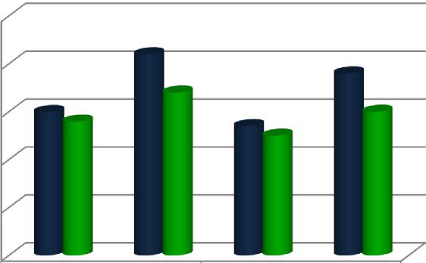

AstraZeneca Eli Lilly
2010
AstraZeneca Eli Lilly
2009

A comparison between the two companies show that Eli Lilly has excellent day to day solvency, more than sufficient cash balances and is under investing and under trading. On the other hand, AstraZeneca has good day to day liquidity, sufficient cash balances and is trading appropriately.
11
Efficiency Ratios
● Inventory Turnover
The inventory turnover helps gain better insights on the stock holding period of a company. This ratio helps understand the demand for the product of a company, the availability of the product and the success of the company in terms of cash flows. The shorter the stock holding period the better is the ability of the company to convert its inventory into cash.
AstraZeneca has an inventory turnover of 96 days which has improved from the previous fiscal. This shows the increase in demand for the company’s products and the ability of the company to take the stock off the shelves and in turn improve the cash flows of the company.
Eli Lilly, on the other hand, has a very high inventory level of 210 days. Pharmaceutical companies are bound to have high inventory levels since having good supply availability is considered to be of prime importance. According to industry standards, the average inventory level of pharmaceutical companies is 170 days. The inventory level of Eli lily needs to be bought down to improve cash flows in the company to cater to better growth and investment opportunities.

Efficiency of AstraZeneca and Eli Lilly

400
350

245
300
250
83
90
200
210

Eli Lilly Astrazeneca
150
66 64
100
50
146
129
96 111 86 86

2010 2009  0  12 | 2010 2009 | 2010 2009
Inventory Turnover | Account receivable | Account Payable
 | Turnover | Turnover

● Account Receivable Turnover
This indicates the time taken by the debtors to clear off their balance. AstraZeneca has an accounts receivable period of 86 days which has remained constant over the two years under consideration. However, payment days for the customers of Eli Lilly have increased from 64 in 2009 to 66 in 2010. Both the companies need to reduce the debtor payment days to ensure better cash flows in the company.
● Accounts Payable
This is the time taken by the company to clear its pending dues. AstraZeneca has an account payable ratio of 129 days which has decreased from the previous years. This could be due to the improving ability of the company to sell off its inventories or an increase in pressure from the creditors.
In 2010, the account payable ratio of Eli Lilly has increased from 83 days in 2009 to 90 days. This may be due to the increase in time taken by the debtors to pay off their debts in the current fiscal. Efforts need to be made by both the companies to keep this ratio as high as possible.

● Working Capital Cycle
Working Capital Cycle

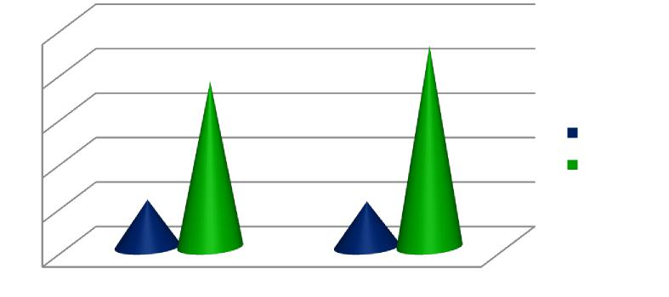
226
250
186
200
150
100
53 51
50
0
2010 2009
Astrazeneca Eli Lilly

This ratio is an indication of the length of time the monetary funds are caught up as a part of the current assets. The working capital of AstraZeneca has increased from 51 days to 53 days while that of Eli Lilly has decreased from 226 days to 186 days. AstraZeneca needs to needs to be cautious on this ratio and make efforts to keep the working capital cycle as low as possible. In Comparison, Eli Lilly has a much bigger investment caught up in the working cycle. The company needs to bring down this investment capital to make available funds for conducting more R&D and thus increasing profitability.
13
Financial Structure
● Gearing
A gearing ratio measures the degree to which a company’s performance and activities is sponsored. This could be through owner’s funds or through creditor’s funds.

Gearing

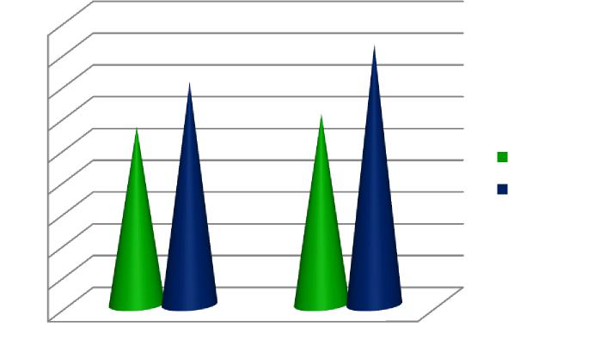
45%
40%
35%
30%
25%
20%
15%
10%
5%
0%
2010 2009
28%
35%
30%
41%
Astrazeneca Eli Lilly

AstraZeneca has a gearing ratio of 30% in 2009 which has decreased by 2% in 2010. The high gearing ratios could be as a result of acquisition of new assets, which is indicated in the decline in return on capital employed and decreasing gross profits and constant net profits. Eli Lilly has managed to decrease its gearing ratios in 2010 by 6%. This could be due to the increase in the net profit obtained in 2010. Both the companies need to ensure that their companies have low gearing ratios to reduce the vulnerability of their business to financial crisis.
14
● Interest Cover
This ratio helps determine the ability of the company to pay off the interest on the outstanding debt. This ratio helps determine the ability of the company to pay off the interest on the outstanding debt. The company is said to be more burdened by debt expense as the value of this ratio decreases. Over the two years, Eli Lilly’s interest cover ratio has increased from 22 times to 36 times while AstraZeneca’s interest cover ratio has increased from 11 to 12 times indicating the improving ability of the company to pay off the interest on debts.

Part D
15
Comparison of International Reporting Practises by the two companies
The two companies under study are known to follow two different International Reporting Practises. AstraZeneca follows International Finance Regulation Standards (IFRS) which are defined by International Accounting Standard Board whereas Eli Lilly follows General Accepted Accounting Principles (GAAP) which are developed by Financial Accounting Standard Board (FASB). While analysing the impact of the two different reporting practises on the performance/financial positions of the
companies we considered the following factors to be significant.
Inventory
AstraZeneca following IFRS uses a first-in, first-out (FIFO) and average cost as its inventory methods. IFRS does not allow the use of the last-in, first-out method (LIFO). While Eli Lilly following GAAP permits the usage of LIFO in its inventory. Under U.S. GAAP, once the inventory is recorded, any consecutive revival of value is ignored while in IFRS this can be recognized.
Property and Equipment
IFRS enables upward revaluation of property and equipment while US Gap prohibits this. Under IFRS, this value is reported in the income statement.
Operating expenses
U.S.GAAP considers expenses and losses as different entity while IFRS does not. Under IFRS, losses not covered under firms primary operations are a part of operating expenses.
Depreciation
U.S. GAAP does not include cumulative adjustments made for prior period depreciation of the life of assets and resources. While IFRS emphasizes that the evaluation method highlights pattern of consumption and should be allocated on a systematic basis over the useful life of an asset.

Nonrecurring Items
16
Over the several years there have been similarities in U.S. GAAP and IFRS in reporting discontinued operations. However, the comprehension of extraordinary items still differs. Under U.S. GAAP, extraordinary item is considered as a material transaction that is unusual in nature and not frequent in occurrence. These are reported in income statement, net of taxes, below earnings from continuing operations. In Contrast, IFRS does not permit such items to be treated in income statement. Required IFRS disclosures may be used to separate recurring and nonrecurring earnings.
Treatment of Interest and Dividends on Cash Flow
Under U.S. GAAP, dividends issued to shareholders are recorded as Cash Flow from Finance (CFF) while interest paid is stated as Cash Flow from Operations (CFO). Interests and Dividends received from investments are also stated as CFO.
IFRS enables more flexibility with respect to treatment of interest and dividends on cash flows. Here interests and dividends received may be recognized as either operating or investing activities (CFO or CFI-Cash Flows from Investment). Dividends issued to shareholders and interest paid on a company’s debt can be recognized as either CFO or CFF.
Revenue Recognition
The main principles for revenue recognition are the same for IFRS and U.S. GAAP. However, GAAP is expected to provide more industry-specific guidance.
Construction contracts
Under U.S. GAAP, if outcome of a project can be reasonably measured then income, expense and profits are recognized while the work is in progress. However, if the outcome cannot be measured then income and won’t be recognized until project completion
Under IFRS, if the outcome cannot be measured reliably, revenue is recognized with respect to contract costs while profits are recognized on project completion.

Conclusion
17
Different Reporting practices haven’t affected our comparative analysis of the two companies. However, while studying these practices in depth and comprehending these different reporting standards we realized that a few adjustments would need to be made in the balance sheet and income statements in order to make the two company’s financials comparable. For e.g. AstraZeneca follows LIFO method while reporting its inventory while Eli Lilly follows FIFO for 45% of its inventory. Many such reporting differences have been identified above. Moreover, today many multinational companies are found dealing with companies across the globe and more than 100 countries across the world now use IFRS as a reporting standard. Hence, we recommend adoption of a standard reporting practice to be followed. Further, our research helps us understand that there is a move towards IFRS across the globe.
Part E
Non-Financial Performance Indicators
The following are the qualitative and quantitative non-financial indicators that we have identified in the two companies.
Manufacturing and Production Indicators
● AstraZeneca
AstraZeneca adopts lean supply and manufacturing tools to improve the efficiency of its manufacturing and supply chain processes. They believe in maintaining rigorous quality standards for their manufacturing facilities and products by subjecting their facilities to inspections by different regulatory authorities. The company works with thousands of suppliers all around the world. The suppliers are chosen after careful assessment of their supplying capabilities and d background check.
● Eli Lily
Eli Lily sources its raw materials from a single source. In case of interruption in supply from this source, Eli Lilly would face an interruption in supply once the stocked up inventory is utilized. The company conducts various chemical tests at different stages of production to ensure that the product meets international product quality and complies with international regulatory requirements.

Marketing and Sales Indicators
18
● Eli Lily
Eli Lilly promotes pharmaceutical products through an efficient sales team. They also advertise their products in medical journals, distribute product samples and product literature. The marketing and sales team is classified on the basis of the functional (therapeutic) area such as neuroscience, diabetes, oncology, etc. A special team caters to the sales queries and issues of wholesalers, managed-care organizations, hospitals, government institutions, etc.
● AstraZeneca
AstraZeneca does not provide much information on the performance of this indicator but does highlight its compliance with international marketing codes and ethics. A nominated network takes care that all current and promotional products meet applicable standards.
Environment
● AstraZeneca
They take the environmental protection into consideration from producing medicines to disposal. Environmental influence is the core commitment for AstraZeneca, compared with the data in 2005, the overall greenhouse gas emission reduced a lot in 2010. They launched the SHE (Safety health environment) strategy to set the direction for the next decades. They have an environment assessment for all established medicines, and they have also set up the Environmental risk management plans to ensure environment protection.
● Eli Lilly
They have constantly strived to improve energy efficiency and reduce water intake, greenhouse gas emissions, quantity of waste generated. The company has implemented green chemistry to reduce the use of hazardous substances in research.
Employees Engagement
AstraZeneca uses various global communication channels to ensure the engagement of the employees in their business strategy. Local leaders conduct regular meetings with their teams. Video conferencing and media tools are also used to encourage employee participation. The company conducts a yearly feedback mechanism called FOCUS for all their employees across the globe which enables them to identify key areas for improvement such as leadership management, change management, work/life balance, etc.

To encourage employee participation, Lilly has adopted an incentive programme composed of salary, equity incentives, performance-based cash and a competitive employee benefits program. They have also customized Global Giving Website which enables employees across the world to participate in its corporate responsibility projects.
19
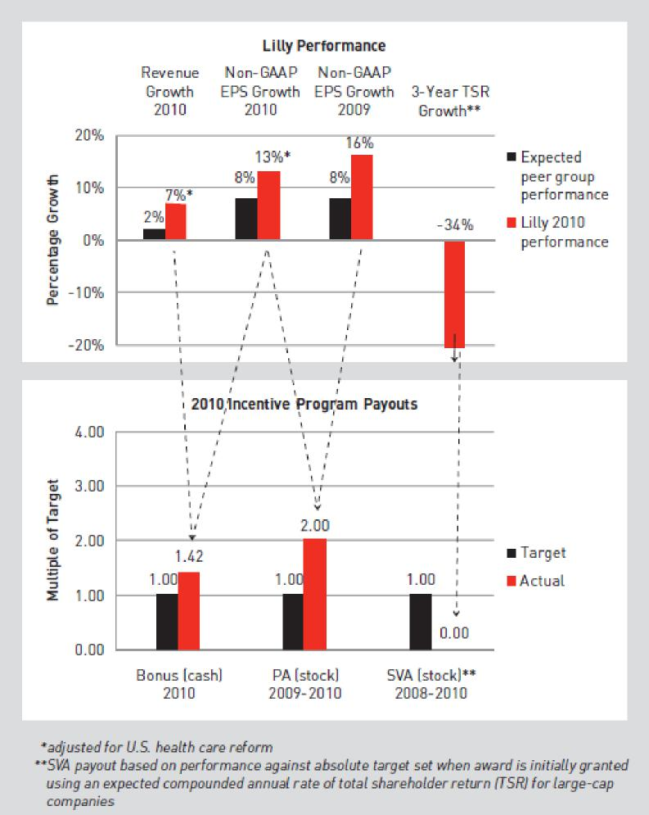
Source: Eli Lilly, Annual report 2010
Community Investment
Eli Lilly’s Global Giving provides employees with an opportunity to gain deeper understanding on the plights of people and community across the world. This year

Lilly introduced a Connecting Hearts Abroad program where employees travel to 10 countries to help the underprivileged people lacking basic necessities.
20
AstraZeneca provides charitable donations to local communities in various forms. They also have a charity program called AstraZeneca Young Health Program aimed at the youth. AstraZeneca has helped various developing nations like Africa to fight diseases such as AIDS, Tuberculosis, etc. They have also supported the people suffering from natural calamities across the world.
References List
AstraZeneca, 2011. Annual report 2010. [Online]
Available at: < http://www.astrazeneca-annualreports.com/2010> [Accessed 22 November 2011].
AstraZeneca, 2011. AstraZeneca - Investors [online] Available at:< http://www.astrazeneca.com/Investors> [Accessed 22 November 2011].
Deloitte, 2010. International Financial Reporting Standards - What it means for private company reporting [online] Available at:< http://www.deloitte.com/view/en_US/us/f7220b98fc001210VgnVCM100000ba42f0 0aRCRD.htm > [Accessed 25 November 2011].
PWC, 2011. IFRS and US GAAP: similarities and differences [online] Available at:< http://www.pwc.com/us/en/issues/ifrs-reporting/publications/ifrs-and-us-gaapsimilarities-and-differences.jhtml> [Accessed 25 November 2011]
Eli Lilly, 2011. Annual report 2010. [Online]
Available at: < http://investor.lilly.com/annuals.cfm> [Accessed 22 November 2011].
Eli Lilly, 2011. Eli Lilly and Company – Investor Relations [online] Available at:< http://investor.lilly.com/> [Accessed 22 November 2011].
Eli Lilly, 2011. Eli Lilly and Company – Environmental Sustainability [online] Available at:< http://www.lilly.com/responsibility/es/Pages/environment.aspx/> [Accessed 22 November 2011].
Stock Analysis on Net, 2011. Eli Lilly & Co. (LLY) | Analysis of Inventory [online] Available at:< http://www.stock-analysis-on.net/NYSE/Company/Eli-LillyCo/Analysis/Inventory> [Accessed 24 November 2011].
Stock Analysis on Net, 2011. AstraZeneca PLC (AZN) | Analysis of Inventory [online] Available at:< http://www.stock-analysis-on.net/NYSE/Company/AstraZenecaPLC/Analysis/Inventory> [Accessed 24 November 2011].

i http://www.stock-analysis-on.net/NYSE/Company/Eli-Lilly-Co/Analysis/Inventory ^{ii}http://www.stock-analysis-on.net/NYSE/Company/AstraZeneca-PLC/Analysis/Inventory
21

