Performance and Financial Position
Analysis
,

Table of contents
1
- Introduction 3
- Analysis of key performance indicators 4
2.1 Profitability analysis 4
2.2 Liquidity analysis 10
2.3 Efficiency analysis 13
2.4. Gearing analysis 15
2.5. Interrelationship of ratios 20
- Limitations of ratio analysis 21
- Conclusions 23
- References 24
Appendix A: Formula collection for ratio analysis 0
Appendix B: Calculations 1
Appendix C: Marshalls’ consolidated balance sheets 2010 to 2007 3
Appendix D: Marshalls’ consolidated income statements 2010 to 2007 5

List of Tables and Figures
2
Figure 2.1: Marshalls’ profitability ratios between 2007 and 2010 4
Figure 2.2: Reconciliation between Marshalls’ 2007 and 2009 revenues 5
Figure 2.3: Reconciliation between Marshalls’ 2009 and 2010 revenues 6
Table 2.4: Movements in revenue by market segment, from 2007 to 2009 7
Table 2.5: Movement in revenue, by market segment, from 2009 to 2010 7
Figure 2.6: Marshalls’ profit percentage ratios (2007-2009) 8
Figure 2.7: Marshalls ROCE, ROE, and ROA ratios (2007 – 2009) 9
Table 2.8: Marshalls’ liquidity ratios between 2007 and 2010 10
Table 2.9: Major components of current assets and current liabilities 11
Figure 2.10: Marshalls’ inventories and receivables between 2007 and 2010 12
Figure 2.11: Marshalls’ efficiency ratios between 2007 and 2010 14
Figure 2.12: Marshalls’ capital structure and gearing between 2007 and 2010 16
Table 2.13: Marshalls’ decomposition of long- term borrowing 17
Figure 2.14: Marshalls’ operating lease between 2007 and 2010 17
Figure 2.15: Marshalls’ operating Income, interest expense, and interest cover between
2007 and 2010 18
Table 2.16: Marshalls’ interest expense between 2007 and 2010 19
Table 2.17: Marshalls’ decomposition of financial expenses 19
Figure 2.18: Interrelated ratios 20
Table 2.19: Marshalls’ decomposition of return on equity 20

1. Introduction
3
Financial statement analysis is an important technique to financial accountants, managers, and others who evaluate the financial health of corporations. (Pink, Holmes, D’Alpe, 2005, p. 5) This technique includes ratio analysis, the study of differences in components of financial statements among industries, review of descriptive material, and comparison of results with other types of data. Financial statement analysis is a judgemental process. One of the primary objectives is identification of major changes in trends, amounts, and relationships and investigation of the reasons underlying those changes. (Gibson, 2011, p. 187)
On the following pages the reader will find a complete performance and financial position analysis for Marshalls. Established in the late 1880s, Marshalls is the UK's leading manufacturer of superior natural stone and innovative concrete hard landscaping products, supplying the construction, home improvement and landscape markets. The Group operates its own manufacturing sites throughout the UK, including a national network of manufacturing and distribution sites. (Marshalls, 2010, p.8) During 2010 and 2009 the group’s main focus has been to respond to the impact of the recession. Against the backdrop of an uncertain economic environment Marshalls has focussed on short term actions to create greater levels of certainty by reducing cost and conserving cash by tight control of working capital and capital expenditure. These actions have been balanced with the need to protect and continue to build on Marshalls’ market leading capability for the medium term. The group’s strategic focus has now turned to recovery and preparation for growth.

2. Analysis of key performance indicators
4
2.1 Profitability analysis
Profitability ratios examine how good management is at turning efforts into profits and ultimately providing its shareholders with an acceptable return. To analyse the profitability of Marshalls, gross profit percentage, operating profit percentage, net profit percentage, return on capital employed, return on equity and return on asset are employed.
The profitability of Marshalls deteriorated drastically over the 2007 – 2010 period as the industry and the market in which the company operates (i.e. building material industry) suffered severely from economic recession. Accordingly, Marshalls’ profitability ratios plunged considerably during this period, with gross profit percentage, operating profit percentage and net profit percentage decreasing as to be seen in Figure 2.1. Likewise, return on asset, return on capital employed and return on equity ratios fell, respectively, from 7.37%, 18.59% and 15.08% in 2007 to 2.10%, 5.16% and 3.71% in 2010.
Figure 2.1: Marshalls’ profitability ratios between 2007 and 2010

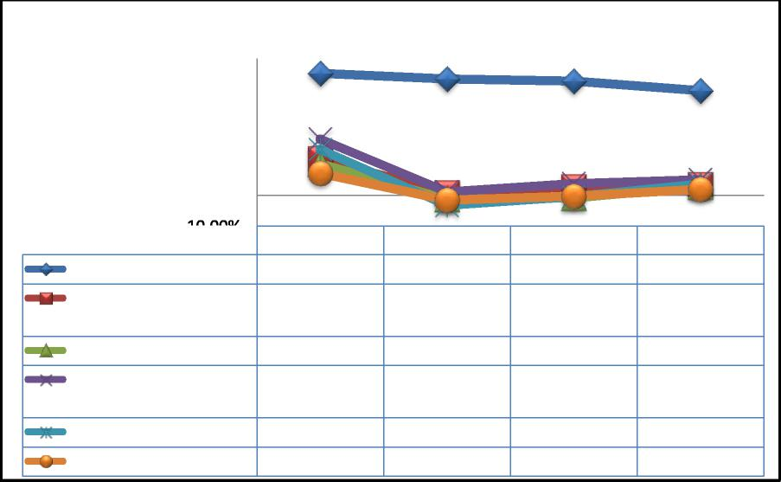
-10.00% | 2007 | 2008 | 2009 | 2010
Gross Profit Percentage | 40.15% | 38.29% | 37.66% | 34.43%
Operating Profit  Percentage | 12.11% | 0.86% | 2.95% | 3.64%
Net Profit Percentage | 10.45% | -1.20% | -0.76% | 2.85%
Return on Capital  Employed | 18.59% | 1.16% | 3.84% | 5.16%
Return on Equity | 15.08% | -3.22% | -0.42% | 3.71%
Return on Asset | 7.37% | -1.55% | -0.20% | 2.10%

45.00%
40.00%
35.00%
30.00%
25.00%
20.00%
15.00%
10.00%
5.00%
0.00%
-5.00%

The deterioration in the company’s profitability was caused by three prime factors: 1. Revenues contracted remarkably due to unfavourable market conditions:
5
During 2007 – 2009, revenues decreased by £91.2 million or 22.64% equivalently, from £402.9 million in 2007 to £311.7 million in 2009. From 2009 to 2010, revenues slightly improved by £11.4 million or 3.7% equivalently, from £311.7 million in 2009 to £323.1 million in 2010.
Decomposing movements in revenues by changes in market and manufacturing factors, it is pointed out that the total decrease in sales volume due to an unexpected market meltdown attributed to a £120.1 million decrease in revenues. In 2009, working days had been cut down by 3 and led to a further decrease of £4.7 million. The fall in revenues was, however, offset partly by an increase in sales price which was £31.3 million in total. In 2010, the small improvement of 3.7% in revenues was due to the partial recovery of the market.
Figure 2.2: Reconciliation between Marshalls’ 2007 and 2009 revenues

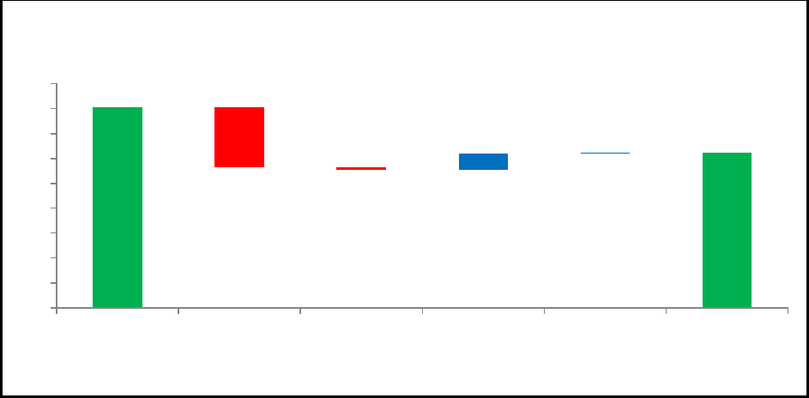
450
400
350
300
250
200
150
100
50
0
(in £000)
402.9
120.1
 |  |  |  |  | 311.7
 |  |  |  | 31.3 | 2.3
 |  |  | 4.7
2007 Sales volume 3 fewer working  days in 2009 |  |  |  | Cost increase  recovered in  sales price | Others 2009

Figure 2.3: Reconciliation between Marshalls’ 2009 and 2010 revenues
6
Decomposing changes in revenues by market segment (including domestic or individual consumer market, public and commercial market), it can be seen that the former segment affected revenues more severely and negatively than the latter. In particular, from 2007 to 2009, whilst revenues from domestic market decreased remarkably by 29%, from £183.2 million to £130 million, revenues from public and commercial market declined at a significantly lesser, but still considerable, pace by 17.2%, from £219.7 million to £181.7 million. This observed phenomenon can be explained as during 2007 – 2009, demands from individual consumers were vastly reduced as the mortgage market was melting down and foreclosures took place extensively. On the other hand, stimulating spending on public constructions from the government had helped to offset the negative impact from the individual consumer market. From 2009 to 2010, revenues from the domestic market improved slightly by 0.5% (from £130 million to £130.7 million) whilst revenues of public and commercial market recovered at quite a greater pace of 5.9% (from £181.7 million to £192.4 million) respectively.

(in £000)
311.7 323.1
10.1 1.3
350
300
250
200
150
100
50
0
2009 Sales volume 1more working day in 2010 2010

Table 2.4: Movements in revenue by market segment, from 2007 to 2009 Decomposing revenues by market segment (in £’000)
7
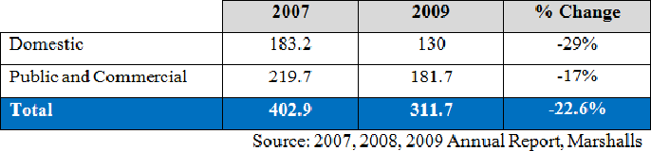
Table 2.5: Movement in revenue, by market segment, from 2009 to 2010
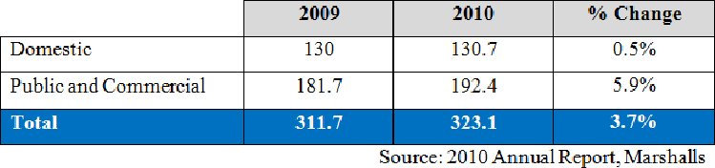
Pressured by a decline in demand and the corresponding decrease in revenues, Marshalls decided to close its manufacturing activities at Sawley, Cannock, Hambrook and Llay in 2008 and 2009. Furthermore the company fired approximately 400 employees (or 14% of total workforce equivalently). This reaction reflects the fact that the cost structure of the company was gradually shifted from being dominated mainly by fixed costs to being based primarily on variable costs.
2. The Company had no robust solution to hedge its exposure to input price:
As it can be seen in Figure 2.6, whilst gross profit percentage declined steadily during the 4-year period, the other 2 ratios depreciated considerably during 2007 – 2008 and recovered gradually from 2008 onwards. However, the overall trend of these ratios was downward sloping.

Figure 2.6: Marshalls’ profit percentage ratios (2007-2009)
8
During 2007 – 2009, revenues, as previously mentioned, decreased by 22.64% whilst the corresponding cost of sales only fell by 19.43%, from £241.2 million to £194.3 million. From 2009 to 2010, although there was a 3.7% improve in revenues, cost of sales unexpectedly inflated at an even faster pace (i.e. 9.04% over the same year), from £194.3 million in 2009 to £211.9 million in 2010. It was this mismatch between the pace of increase/decrease in revenues and the pace of increase/decrease in cost of sales that made the gross profit percentage decline continuously during the period. This also points out that the company was incapable of hedging its exposure to the input price (mainly cement and diesel which skyrocketed during the concerned period).

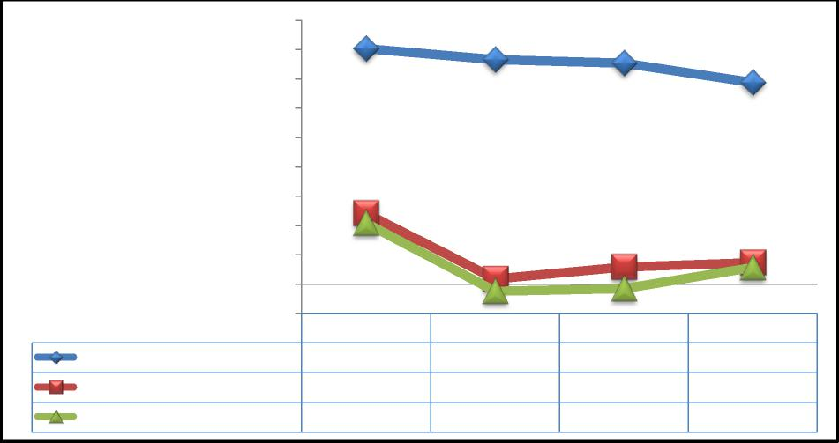
2007 | 2008 | 2009 | 2010
40.15% | 38.29% | 37.66% | 34.43%
12.11% | 0.86% | 2.95% | 3.64%
10.45% | -1.20% | -0.76% | 2.85%

45.00%
40.00%
35.00%
30.00%
25.00%
20.00%
15.00%
10.00%
5.00%
0.00%
-5.00%
Net Profit Percentage
Gross Profit Percentage
Operating Profit Percentage
With regards to operating profit percentage, the remarkable decrease from 12.11% in 2007 to 0.86% in 2008 was due to a decline in revenues and inflated expenses caused by the closure costs related to the process of closing 4 manufacturing sites. In particular, closing costs amounted to £27 million in 2008 and without these costs; operating profit percentage would have been 8.9% in 2008 instead. From 2008 to 2010, whilst revenues kept decreasing by 14.5%, operating costs decreased at a faster pace at 16% and therefore, the ratio had improved during the concerned period. From the aforementioned analysis, this improvement could be explained as

the result of the act of closing factories and laying off employees. However, in our opinion, this improvement is temporary and not robust as there is no guarantee as to whether the company could maintain or further improve the ratio when the market and demand recovers in the future.
9
3. Gearing increases unnecessarily amid market meltdown:
With respect to net profit percentage, the considerable decrease of the ratio to - 1.20% in 2008 from 10.45% in 2007 was due to the reasons mentioned in (1) and (2) and a 62% increase in both current and non-current interest bearing loans and borrowings (from £69,105 million in 2007 to £111,868 million in 2008). The improvement in net profit percentage from 2008 onwards was mainly due to a 36.62% reduction of foregoing debt, from £111,868 million in 2008 to £70,900 million in 2010, in the company’s capital structure. Marshalls’ capital structure will be further analysed in section 2.4.
With regard to ROCE, ROE and ROA, as to be seen in figure 2.7, all three ratios displayed the same pattern (i.e. started with a sharp decrease over the 2007 – 2008 period and recovered gradually from 2008 onwards).
Figure 2.7: Marshalls ROCE, ROE, and ROA ratios (2007 – 2009)

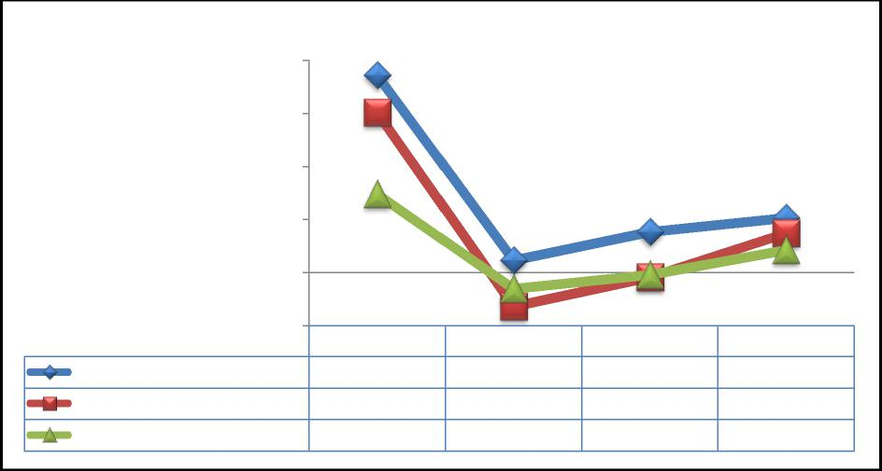
2007 | 2008 | 2009 | 2010
18.59% | 1.16% | 3.84% | 5.16%
15.08% | -3.22% | -0.42% | 3.71%
7.37% | -1.55% | -0.20% | 2.10%

20.00%
15.00%
10.00%
5.00%
0.00%
-5.00%
Return on Asset
Return on Capital Employed
Return on Equity

This pattern was caused mainly by movements in operating profit and net profit as previously mentioned. This not only shows that the profitability, as mentioned at the beginning, was evaporating drastically but also confirms that those who are holding the company’s shares are facing the risk that the spread between return on their investment and equivalent risk-free instruments is being narrowed whilst Marshalls’ risk is unchanged or increased.
10
2.2 Liquidity analysis
Liquidity ratios concern with the ability of the business to meet its short-term financial obligations. (McLaney, Atrill, and Dawsonera, 2010, p. 250-252) To analyse the liquidity of Marshalls, current ratio and quick ratio are employed. In general, a higher ratio is preferable to a lower ratio. As to be seen in table 2.8, Marshalls’ current ratio improved slightly from 1.3 in 2007 to 1.6 to 2009, whilst in 2010, the ratio fell back to 1.2. With regard to quick ratio, movements were minimal with the numbers being around 0.5 during 2007 – 2009. However, in 2010, the ratio plunged to 0.3.
Generally, Marshalls’ balance sheet shows that inventories accounted for approximately 68% of the company’s current assets (4 – year average, from 2007 to 2010). This is because Marshalls operates mainly in the building material industry which requires a significant amount of inventories for maintaining normal operation. Besides, the firm’s balance sheet also points out that the current liabilities contain no less than 61% of trade and other payables (4 – year average, from 2007 to 2010) which facilitates that the company achieved its short term financial flexibility.
Table 2.8: Marshalls’ liquidity ratios between 2007 and 2010
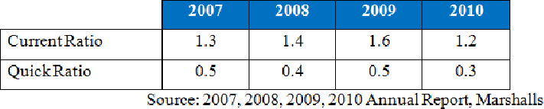

Table 2.9: Major components of current assets and current liabilities
11
 | 2007 | 2008 | 2009 | 2010
Current Assets | 134,004 | 122,577 | 122,737 | 113,610
- Inventories | 82,920 | 89,814 | 82,187 | 81,626
- Cash and cash equivalents | 19 | 538 | 9,283 | 4,059
Current Liabilities | 104,020 | 89,064 | 77,132 | 94,616
- Trade and other payables | 60,236 | 61,780 | 53,248 | 48,552
- Bank overdrafts | 27,840 | 0 | 0 | 0
- Interest bearing loans and  borrowings | 7,234 | 23,429 | 20,039 | 40,900
Source: 2007, 2008, 2009, 2010 Annual Report, Marshalls 1. Movements in inventories and trade and other receivables (during 2007 – 2008)
In 2008, due to an increase in inventories and a decline in trade and other receivables, current ratio improved from 1.3 to 1.4 whereas quick ratio declined to 0.4 from its previous level of 0.5.
The increase in inventories was a result of unfavourable market conditions triggered by economic recession. Accordingly, during the concerned period, the company experienced difficulties in maintaining its normal business and suffered a significant decrease in sales volume and profitability. As a consequence, there was a considerable and unexpected increase in finished goods and goods for resale. Moreover, high inflationary factors had influence on raw material costs (diesel and cement, in particular) adding £6.5 million to inventories. However, the foregoing effects were partially offset by the liquidation of £6 million of inventory from the closure of the Marshalls’ manufacturing factories at Cannock and Sawley.
Marshalls made efforts to reduce its exposure to liquidity risk by reducing its current liability from £104 million in 2007 to £89.1 million in 2008. This was achieved through a reduction of nearly £30 million of bank overdrafts in 2008 indicating that the company had improved its control over cash outflows.

Figure 2.10: Marshalls’ inventories and receivables between 2007 and 2010
12
- Impacts from inventory reduction programme and movements in current liabilities (during 2008 – 2009):

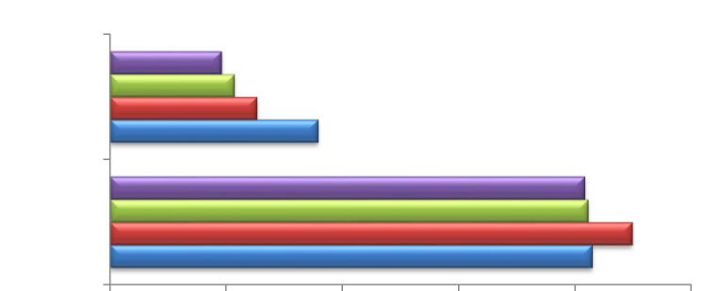
Receivables
21,325
25,240
Inventories
89,814
82,920
in £000)
19,151
35,731
81,626
82,187
- 20,000 40,000 60,000 80,000 100,000

 | Inventories | Receivables
2010 | 81,626 | 19,151
2009 | 82,187 | 21,325
2008 | 89,814 | 25,240
2007 | 82,920 | 35,731

Both the current ratio and quick ratio increased in 2009. Due to the impact of the inventory reduction programme, inventories were brought down from £89.8 million to £82.2 million whilst cash and cash equivalents increased from £0.5 million to £9 million which greatly improved Marshalls’ liquidity. Furthermore, liquidity was enhanced by the reduction of current liabilities. Therefore, it can be inferred that the management team had done well to improve the company’s liquidity.
- Opposite changes in current assets and liabilities (during 2009 – 2010)
In 2010, Marshalls’ liquidity deteriorated significantly to its 4 – year low level. Current ratio and quick ratio plunged to 1.2 and 0.3 respectively indicating that the company might face difficulties meeting its current obligations. This trend was mainly driven by opposite movements in the current assets and liabilities. In 2010, the firm’s current assets dropped down by nearly £9 million as cash, cash equivalents, trade, and other receivables decreased by £5 million and £4 million

respectively. The decline in trade and other receivables was mainly due to a shortened receivables payment period. In contrary, the Marshalls’ current liabilities in 2010 were escalated by £17 million, from £77 million in 2009 to £94 million in 2010, mainly due to a significant increase in short-term interest bearing loans and borrowings. Accordingly, the figure for 2010 was twice as high as in 2009 (£41 million in 2010 in comparison to £20 million in 2009). The need for business restructuring and recovery might play an important role behind this increase in short – term liabilities.
13
2.3 Efficiency analysis
Efficiency ratios point out the effectiveness of a company’s working capital management. To analyse the efficiency of Marshalls, four indicators were used: inventory holding period, receivables payment period, payables payment period and working capital cycle. Generally, a short inventory holding period is preferable as it reduces the costs of holding inventories. (McLaney, Atrill, and Dawsonera, 2010, p. 244-246) The working capital cycle gives an insight on the length of the period during which cash is tied up in current assets.
As to be seen in figure 2.11, Marshalls’ receivables payment period decreased from 33 days in 2007 to 22 days in 2010 whilst payables payment period increased from 48 days in 2007 to 56 days in 2010. The working capital cycle had a similar development (i.e. the situation became worse from 2007 to 2009 and improved in 2010).

Figure 2.11: Marshalls’ efficiency ratios between 2007 and 2010
14
In 2007, inventory holding period was 126 days. The result was acceptable as Marshalls operates in the building material industry where inventory holding periods are longer. Receivables and payables payment period were 33 days and 48 days respectively, contributing to a 111 day of working capital cycle. The results implied that the company had managed its working capital effectively.

(days)
180

160 140 120 100

80
60
40
20

0 | 2007 | 2008 | 2009 | 2010
Inventory holding period | 126 | 141 | 155 | 141
Receivables payment period | 33 | 25 | 25 | 22
Payables payment period | 48 | 50 | 54 | 56
Working capital cycle | 111 | 116 | 126 | 107

In 2008, inventory holding period increased from 126 days to 141 days which resulted from increasing inventories and decreasing cost of sales. As mentioned in the liquidity analysis, the increasing inventories were due to the economic recession. Profitability analysis also pointed that there was a £7 million fall in cost of sales reflecting that the company started to reduce its operating cost to deal with unfavourable market conditions. Receivables and payables payment period indicated positive signals for working capital management. Accordingly, receivables payment period fell to 25 days and payables payment period increased to 50 days showing that Marshalls tightened its credit policy and prolonged its payment period to creditors. However, working capital cycle was five days longer than last year (116 days in 2008 in comparison to 111 days in 2007) which was mainly affected by the inventory turnover.

In 2009, inventory holding period was longer, rising to 155 days. Although inventories had decreased by £7 million, cost of sales decreased at an even faster pace. A nearly £40 million decrease in cost of sales reflected weak sales and the result of Marshalls cost saving strategy. Accordingly, receivables payment period remained at the same level as in the year before, payables payment period was longer. In 2009, working capital cycle was 10 days longer than that of 2009 (126 days in 2009 in comparison to 116 days in 2008). 126 days of working capital cycle might indicate that the company’s working capital management is not sufficiently as well.
15
In 2010, the situation improved. Inventory holding period fell from 155 days to 141 days. The economic upturn contributed to better sales and a £20 million increase in cost of sales. Inventories decreased slightly showing that the company has matched its inventories to the improved market conditions. As for receivables and payables management, the company made progress in further shortening receivables payment period and extending payables payment period. And the result of 107 days working capital cycle showed that Marshalls used its working capital efficiently.
2.4. Gearing analysis
A company's capital structure describes the composition of its long-term capital, which usually consists of a combination of long-term borrowing (debt) and equity. Debt comes in the form of bonds or long-term notes payable, whilst equity is classified as common stock and retained earnings. “Analysing the manner in which a business is financed is cardinal in ascertaining the risks associated with investing in or lending to it. A company heavily financed by debt poses greater risk partly because the increased borrowings increase the amount of money which must be found to service the debt. Borrowing also affects the volatility of shareholders return on investment depending on the business cycle.” (Stewart 2011, AFF Handout) In evaluating Marshall’s capital structure over the last four years, gearing ratio, which is a proportion of long-term borrowing to total finance is employed.

The effects of gearing on Marshalls cash flows is measured using the interest cover ratio, which is the amount of profits before interest and tax divided by the interest charge for the year.
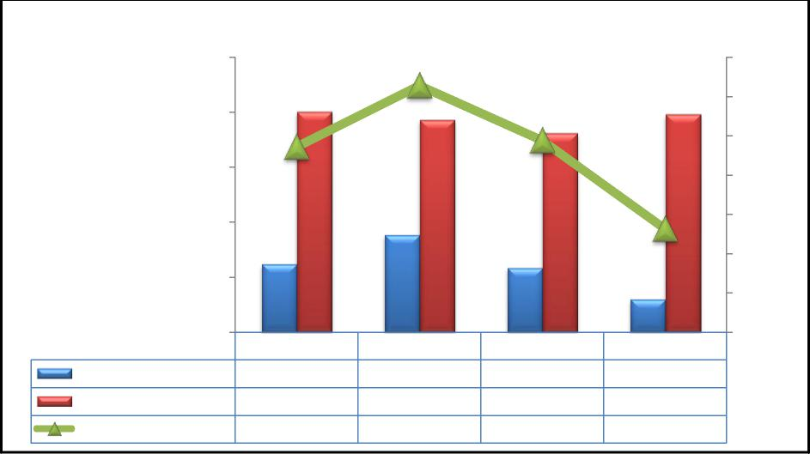
Gearing
Long-term Borrowing
Equity
250,000
200,000
150,000
100,000
(in £000)
50,000
-
23.57%
61,871
200,641
23.57%
61,871
2007
200,641 193,237 198,240
181,099
31.40%
88,439
193,237
31.40%
88,439
2008
24.38%
58,400
181,099
24.38%
58,400
2009
13.14%
30,000
198,240
13.14%
30,000
2010
0.00%
35.00%
30.00%
25.00%
20.00%
5.00%
15.00%
10.00%
16
Gearing
Marshalls gearing ratio declined significantly from 2008 to 2010 after an initial increase from 2007 to 2008. This was a result of both changes in shareholders’ equity and long-term borrowing. Due to uncertainties in the market triggered by economic recession, Marshalls made a conscious effort in building flexibility into its business by reducing its long-term borrowing from 2008, whilst retaining sufficient capacity for the medium term through various uncommitted bank facilities so that the company can react quickly and effectively to the changing market conditions. Marshalls’ policy is to arrange funding ahead of requirements and to maintain sufficient un-drawn committed bank facilities.
Figure 2.12: Marshalls’ capital structure and gearing between 2007 and 2010

As of 2007 year end, the company’s long-term borrowing consisted of bank borrowings, 11.375 per cent £20.0 million debenture stock and financial lease liabilities. On 30th June 2007 Marshalls redeemed all its outstanding preference shares (B shares). The 11.375 per cent £20.0 million debenture stock was repayable at par on 30th June 2014 or, at the company’s option, before then.
17
Table 2.13: Marshalls’ decomposition of long- term borrowing (in £000)
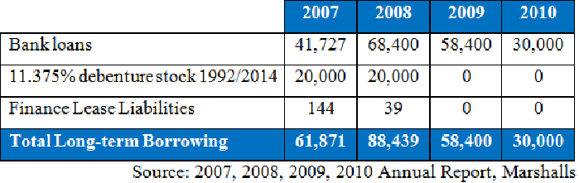
In 2009 Marshalls’ shareholders provided additional funds of £34.0 million through a rights issue to redeem the expensive debenture which provided additional financial headroom at a time of uncertainty. This, however, did not increase equity due to the cumulative effects of losses incurred in 2008 and 2009. Gearing was reduced drastically from 31.40 % in 2008 to 13.14% in 2010 due to the substantial decrease in long-term borrowing.
Although the company had settled all its finance lease liabilities by 2009, it maintained a non-cancellable operating lease over the years. It will be useful to examine the effect of such off the balance sheet financing on the gearing ratio and profitability of the company since an expense is recognised in the income statement over the period.
Figure 2.14: Marshalls’ operating lease between 2007 and 2010 (in £000)
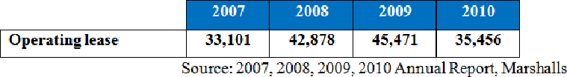

Interest Cover
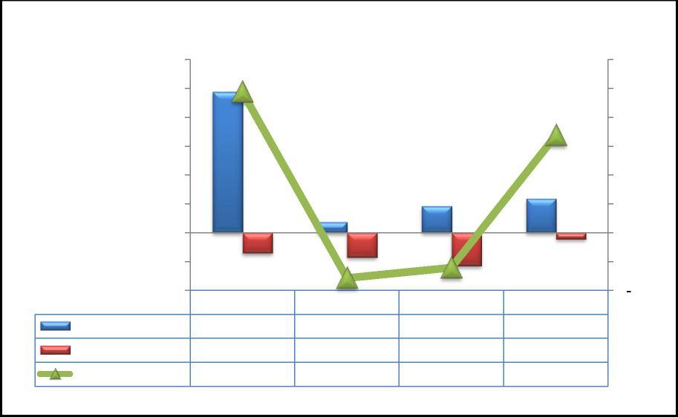
Opearting Income
Interest Expense
Interest Cover
(10,000)
(20,000)
(in £000)
40,000
60,000
50,000
30,000
20,000
10,000
-
48,810
48,810
(7,090)
2007
6.88
11,771
9,192
(7,090) (8,521) (11,554) (2,186)
3,627
6.88
(8,521)
3,627
2008
0.43
0.43 0.80
(11,554)
9,192
2009
0.80
(2,186)
11,771
2010
5.38
5.38
4.00
8.00
7.00
6.00
5.00
3.00
2.00
1.00
18
Marshalls’ interest cover ratio fell sharply from 6.88 in 2007 to 0.43 in 2008 due to 93% decrease in operating income and 20% increase in interest expense during the concerned period. The company took steps to improve its interest cover in 2009 by using the proceeds of the rights issued to redeem the debenture; however, the effect of this action was only realised in 2010.
From 2008 to 2009, although interest expense on bank loans and overdrafts fell by 65.5%, the interest expense continued to escalate. This was due to the redemption premium of £7.3 million. The 65.5% decrease in interest expense on bank loans and overdrafts was mainly due to lower interest rates on bank borrowings as a result of quantitative easing, but also to lower levels of debt. With the increase in operating income and reduction in gearing, the interest cover improved to 5.38 in 2010.
Figure 2.15: Marshalls’ operating Income, interest expense, and interest cover between 2007 and 2010

Table 2.16: Marshalls’ interest expense between 2007 and 2010 (in £000)
19
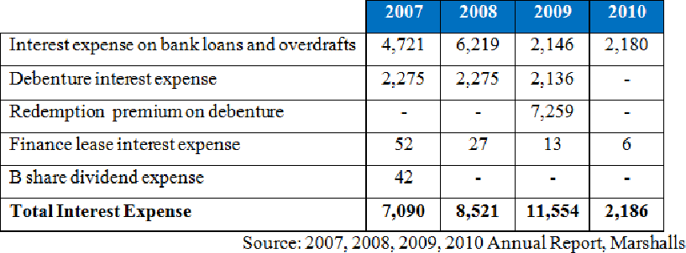
A substantial amount of interest was paid on the company’s obligations under the defined benefits pension scheme which adds to the interest burden. In order to assess the company’s ability to cover all its interest expenses, the interest on obligations under the defined benefit pension scheme is added to the other interest expense to compute the interest cover ratio.
Table 2.17: Marshalls’ decomposition of financial expenses (in £000)
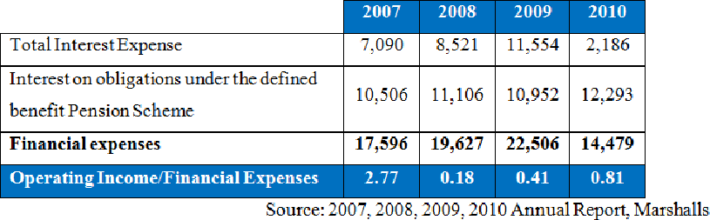

2.5. Interrelationship of ratios Figure 2.18: Interrelated ratios
20
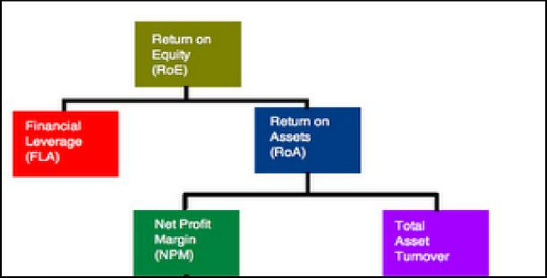
The purpose of any business is to maximize shareholder wealth, which can be measured by the return on equity ratio. This ratio is useful in assessing the financial performance and position of Marshalls in order to evaluate the inter-relationship of profitability, efficiency, and gearing ratios. This analysis will provide further information to understand the source of superior (or inferior) return over the four years.
Marshall’s return on equity can be expressed as the product of its profitability (measured by the net profit after tax margin), asset use efficiency (measured by the asset turnover) and its financial leverage as shown in table 2.19 below:
Table 2.19: Marshalls’ decomposition of return on equity (in £000)
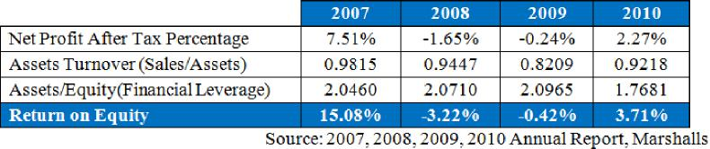

The asset turnover ratio is useful to determine the amount of sales that is generated from each pound sterling of assets. It measures the efficiency of the company's use of its assets in generating sales revenue. Marshalls’ asset turnover ratio from 2007 to 2010 was fairly constant averaging 0.92, with the biggest variance in 2009 as a result of the 22.64% dip in revenues from 2007 to 2009. The asset to equity ratio was on average 2.0 over the period indicating that 50% of the assets are owned by the Marshalls and the other 50% are financed through debt. This level of gearing had a multiplying effect on net profit (loss) margin. In 2007 and 2010, Marshalls benefited from the high gearing but during the business downturn in 2008 and 2009, the loss to equity shareholders was doubled. In conclusion, the main value driver of Marshalls’ return on equity over the period was its net profit margin and the multiplying effect of the high level of gearing.
21
3. Limitations of ratio analysis
Ratio analysis is a useful tool since it facilitates analysts in quickly drawing a general picture about the financial position and performance of a firm. However, based on our foregoing analysis, we could infer the following limitations inherent in the analysis of financial ratios:
Firstly, ratio analysis, in our opinion, is more useful in identifying the questions that need to be answered rather than answering questions directly. For example, in analyzing the profitability of Marshalls through its profitability ratios, we could figure out the trend of the firm’s financial performance over time and the corresponding questions concerning this trend that need to be answered. However, the profitability ratios themselves provide no information to answer such questions and a reference to financial statements is required.
Secondly, financial ratios provide limited information about the financial position and financial performance of the company when viewed isolated. As to be seen in the aforementioned parts of this assignment, we could conclude from the ratio analysis whether or not the financial aspects of the company have been improved or deteriorated. Without referencing to the ratios of other competitors, we cannot
conclude whether the company has outperformed or underperformed in its industry.
22
Thirdly, it is difficult to make an appropriate comparison as different companies employ different accounting treatments. For example, while Marshalls employs FIFO as its cost flow assumption, its competitors in the U.S. might have a different treatment which would make it difficult to make a comparison.
Fourthly, negative financial ratios, which usually appear during periods of business slowdown, are meaningless and incomparable.
Besides ratio analysis, there are other useful financial analysis techniques:
The first and well – known technique is common – size financial statements. In this technique, financial statements can be restated horizontally or vertically. In vertical common – size financial statements, each item on the balance sheet is expressed as a percentage of total assets and each item on income statement and statement of cash flow is expressed as a percentage of revenues. In horizontal common – size financial statements, each item is presented as a percentage of its value in a base year. By using common – size financial statements, one could quickly view certain financial ratios as well as evaluate the performance of the firm over time and make comparisons between firms.
In addition, graphs (e.g. stacked column million graphs, line graphs, pie charts, etc.) are used to quickly illustrate movements in financial position and performance over time. Furthermore, analysis of the inter-relation of financial ratios may also be used. In this technique, one ratio is broken down into various components, each of which represents another ratio. By using interlink analysis one could infer the drivers by which movement in the concerned ratio is triggered.

4. Conclusions
23
From an accounting point of view we analysed the financial performance of Marshalls from 2007 to 2010 and we can conclude that the company faced serious financial problems due to the weather conditions and the overall economic development.
In summary, Marshalls’ profitability has been deteriorated significantly since 2007 due to unfavourable market conditions, the firm’s incapability in hedging exposure to input price and an unnecessarily increase in gearing. However, from 2008 onwards, there has been a slight and gradual improvement in the firm’s profitability. This improvement was mainly due to the partial recovery of the market and savings from closing factories, laying off employees and paying back a portion of its long-term borrowings (a shift in cost structure from fixed costs to variable costs).
Marshalls’ liquidity enhanced from 2007 to 2009. This development was caused by the implementation of short–term cost saving solutions. However, the deterioration of its liquidity in 2010 to a 4 year low implies that the company still faces significant liquidity risk. Marshalls Group was able to manage its receivables and payables payment period sufficiently during the period. However, the company’s inventories holding period had a great impact on its working capital cycle. Poor inventories management attributed to extending of the working capital cycle, destroying the efficiency of working capital. Therefore, improvements in inventory control are required.
Gearing ratios have also decreased which is most important for investors since it means that the company does not have any debt to pay. The interest cover ratio fell sharply from 6.88 in 2007 to 0.43 in 2008 due to the 93% decrease in operating income and the 20% increase in interest expense. The company took steps to improve its interest cover in 2009 by using the proceeds of the rights issued to redeem the debenture; however, the effect of this action was only realised in 2010.

5. References Books:
24
- Accounting : an Introduction, Financial Times/Prentice Hall, by E. J. McLaney, Peter Atrill and Dawsonera, 2010
- Financial Reporting & Analysis: Using Financial Accounting Information, Charles H. Gibson, 12th Edition, South Western, 2011
Internet:
- Financial Indicators for Critical Access Hospitals, University of Minnesota, G. Pink PHD, M. Holmes PHD, 2005, Link: http://www.flexmonitoring.org/documents/BriefingPaper7_FinancialIndicat ors.pdf
- Marshalls Annual report 2010, Marshalls Group,Taylor Bloxham Limited, 2010, Link:
http://online.hemscottir.com/ir/mslh/pdf/annual_report_accounts_2010.pdf
- Marshalls Annual report 2010, Marshalls Group,Taylor Bloxham Limited, 2009, Link:
http://online.hemscottir.com/ir/mslh/pdf/annual_report_accounts_2009.pdf
- Marshalls Annual report 2010, Marshalls Group,Taylor Bloxham Limited, 2008, Link:
http://online.hemscottir.com/ir/mslh/pdf/annual_report_accounts_2009.pdf
- Marshalls Annual report 2010, Marshalls Group,Taylor Bloxham Limited, 2007, Link:
http://online.hemscottir.com/ir/mslh/pdf/2007_annual_report.pdf

Appendix A: Formula collection for ratio analysis
Profitability Ratios
- Gross profit percentage |  | Gross Profit  100  x
 |  | Revenues
- Operating profit percentage |  | Profit before deducting interest and taxation (Operating Profit)  x100
 |  | Revenues
- Net profit percentage |  | Net Profit before taxes  x100
 |  | Revenues
- Return on Capital Employed |  | Profit before deducting interest and taxation (Operating Profit)  x100
 |  | Equity + Long — term Borrowing (Debt)
- Return on Equity |  | Net Profit after taxes  x100
 |  | Equity
- Return on Asset |  | Net Profit after taxes  x100
 |  | Total Assets
Liquidity Ratios
- Current Ratio |  | Current Assets
 |  | Current Liabilities
- Quick Ratio (Acid Test) |  | Current Assets less Inventory
 |  | Current Liabilities
Efficiency Ratios
- Inventory Holding Period |  | Inventory  x365
 |  | Cost of Sales
- Receivables Payment Period |  | Trade receivables  x365
 |  | Revenues
- Payables Payment Period |  | Trade payables  x365
 |  | Cost of Sales
- Working capital cycle | Inventory Holding Period + Receivables Payment Period — Payables Payment Period

Gearing Ratios
1
 | Gearing | Long — term Borrowing
 |  | Equity + Long — term Borrowing
 | Interest Cover | Profit before deducting interest and taxation (Operating Profit)
 |  | Interest Expense

Appendix B: Calculations
 |  | 2007 | 2008 | 2009 | 2010
Profitability Ratios
 | Gross profit percentage | 161,774  40.15% | 144,755  38.29%  — | 117,832  37.66%  — | 111,232  34.43%  —
 |  | 402,926 — | 378,063 | 311,685 | 323,104
 | Operating profit percentage | 48,810  12.11%  — | 3,267  0.86%  — | 9,192  2.95%  — | 11,771  3.64%  —
 |  | 402,926 | 378,063 | 311,685 | 323,104
 | Net profit percentage | 42,103  10.45%  — | (4,527)  — —1.20% | (2,370)  — —0.76% | 9,213  2.85%  —
 |  | 402,926 | 378,063 | 311,685 | 111,232
 | Return on Capital Employed | 48,810  18.59%  — | 3,267  1.16%  — | 9,192  3.84%  — | 11,771  5.16%  —
 |  | 262,512 | 281,676 | 239,449 | 228,240
 | Return on Equity | 30,251  15.08%  — | (6,221)  3.22%  — — | (752)  — —0.42% | 7,350  3.71%
 |  | 200,641 | 193,237 | 181,099 | —  198,240
 | Return on Asset | 30,521  7.37%  — | (6,221)  1.55% — — | (752)  — —0.2% | 7,350  2.10%  —
 |  | 410,519 | 400,192 | 379,680 | 350,516

Liquidity Ratios

- Current Ratio
- Quick Ratio (Acid Test)

Efficiency Ratios

- Inventory Holding Period
- Receivables Payment Period

- Payables Payment Period
- Working capital cycle
 | 126 + 33 - 48 =111 days |  |  | 141 + 25 - 50 =116 days |  |  | 155 + 25 - 54 =126 days |  |  | 141 + 22 - 56 =107 days
Gearing Ratios
- Gearing
- Interest Cover

Source: 2007, 2008, 2009, 2010 Annual Report, Marshalls
2

Appendix C: Marshalls’ consolidated balance sheets 2010 to 2007
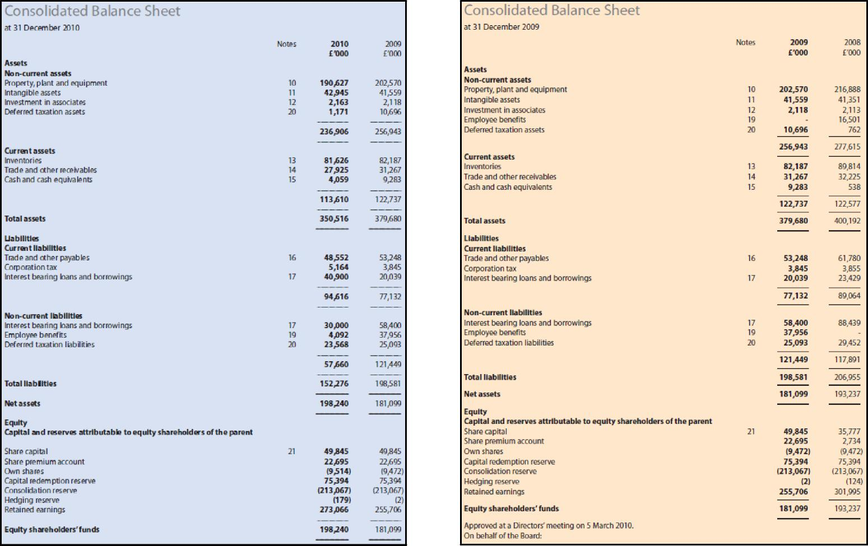

Consolidated Balance Sheet
at 31 December 2008
Assets
Non-current assets
Property.. plant and equipment
Intangible assets
Investment in associates
Employee benefits
Deferred taxation assets
Current assets
Inventories
Trade and other receivables Cash and cash equivalents Assets held for sale
Total assets
Liabilities
Current liabilities
Bank overdraft
Trade and other payables
Corporation tax
Interest bearing bans and borrowings
Non-current liabilities
Interest bearing loans and borrowings Employee benefits
Deferred taxation liabilities
Total liabilities Net assets
Equity
Capital and reserves attributable to equity shareholders of the parent
Share capital
Share premium account
Own shares
Capital redemption reserve
Consolidation reserve
Hedging nerve
Retained earnings
Equity shareholders' funds

2008 | 2007
£'000 | E040
216,888 | 209,313
41,351 | 60,147
2,113
16,501
762 | 7,055
277,615 | 276515
89,814 | 82,920
32,225 | 44866
538 | 19
 | 8,199
122,577 | 134,004
400,192 | 410,519
 | 27,840
61,780 | 60,236
3,855 | 8,710
23,429 | 7,234
89,064 | 104,020
88,439 | 61,871
 | 17,795
29,452 | 26,192
117..891 | 105,858
206,955 | 249,878
193,237 | 200,641
35..777 | 35,777
2,734 | 2334
(9..472) | (8,866)
75..394 | 75,394
(213..067) | 1213,067)
(124) | (31
301,995 | 308,672
193,237 | 200,641

Notes
10
11
12
20
21
13
14
15
16
15
17
18
18
20
21
NNNN
Consolidated Balance Sheet

at 31 December 2007
 | Notes | 2007 | 2006
 |  | c000 | £'040
Assets
Non-current assets
Property, plant and equipment | 9 | 209,313 | 202,941
Intangible assets | 10 | 60,147 | 52,667
Deferred taxation assets | 19 | 7.055 | 15,018
 |  | 276.515 | 270,626
Current assets
Inventories | 11 | 82,920 | 68,256
Trade and other receivables | 12 | 42,866 | 34,290
Cash and cash equivalents | 13 | 19 | 22
Assets held for sale | 14 | 8,199
 |  | 134,004 | 102,368
Total assets |  | 410519 | 373,194
Liabilities
Current liabilities
Bank overdraft | 13 | 27,840 | 999
Trade and other payables | 15 | 60,236 | 57,362
Corporation tax |  | 8,710 | 8,185
Interest bearing loans and borrowings | 16 | 7,234 | 3565
 |  | 104,020 | 70,111
Non-current liabilities
Interest bearing loans and borrowings | 16 | 61,871 | 50,064
Employee benefits | 18 | 17,795 | 41,945
Deferred taxation | 19 | 26,192 | 26532
 |  | 105,858 | 118541
Total liabilities |  | 249,878 | 188,652
Net assets |  | 200,641 | 184542
Equity
Capital and reserves attributable to equity shareholders of the parent
Share capital | 20 | 35,777 | 35,777
Share premium account | 20 | 2,734 | 4732
Own shares | 20 | 18,866) | (453)
Capital redemption reserve | 20 | 75,394 | 73,298
Consolidation reserve | 20 | (213,067) | (213,067)
Hedging reserve | 20 | 13) | (6)
Retained earnings | 20 | 308,672 | 286,26T
Equity shareholders' funds |  | 200,641 | 184,542

4

Appendix D: Marshalls’ consolidated income statements 2010 to 2007
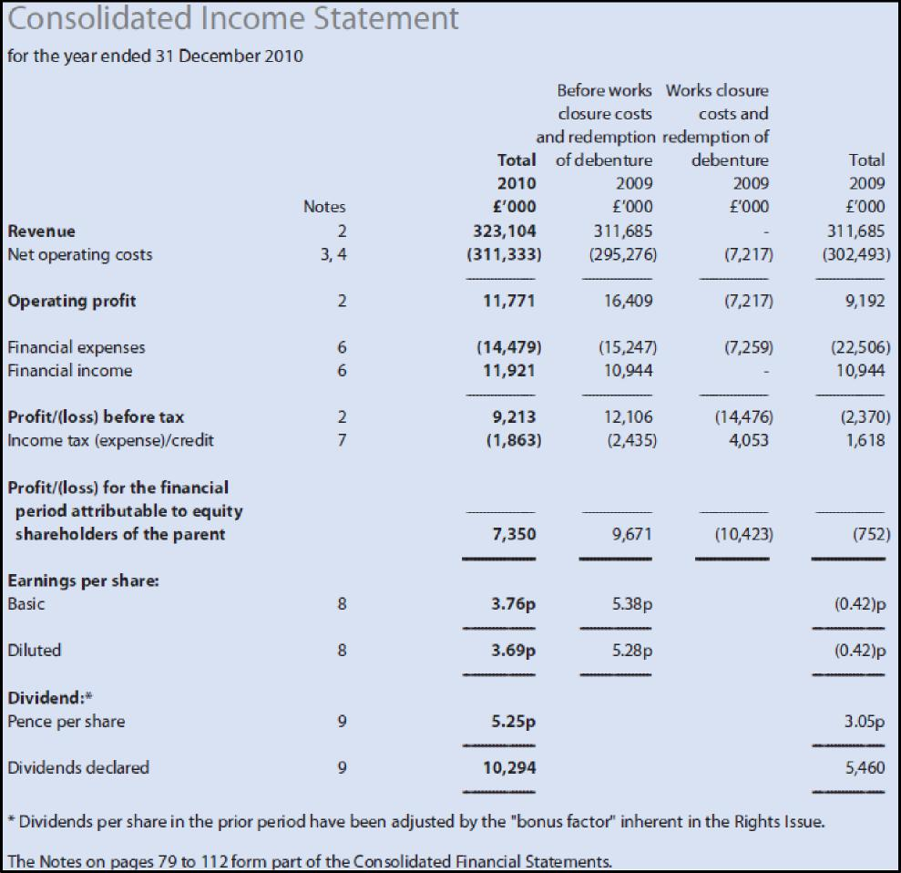

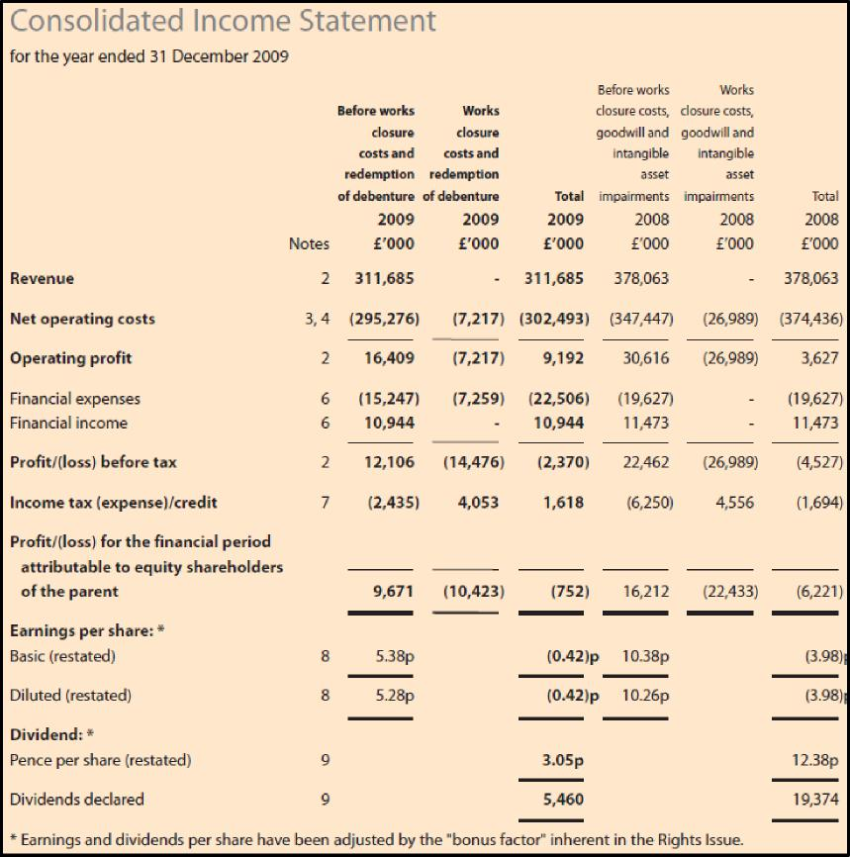
6

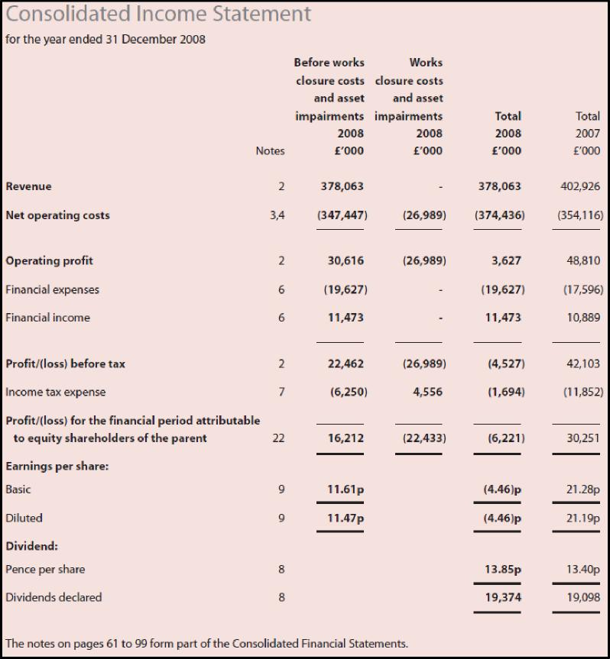
7

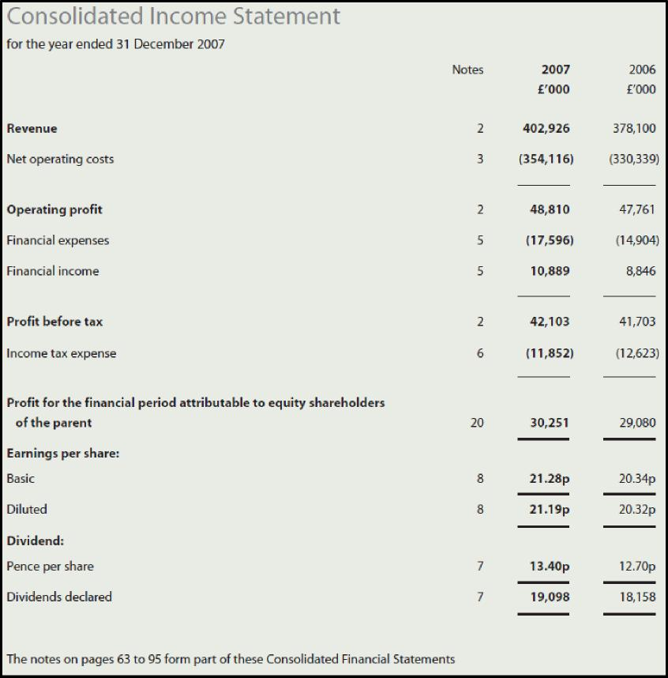
8

